Democratizing Higher Education—Experiments Old Westbury Oral History Project
Carol Quirke
American Studies Department--SUNY Old Westbury
2018

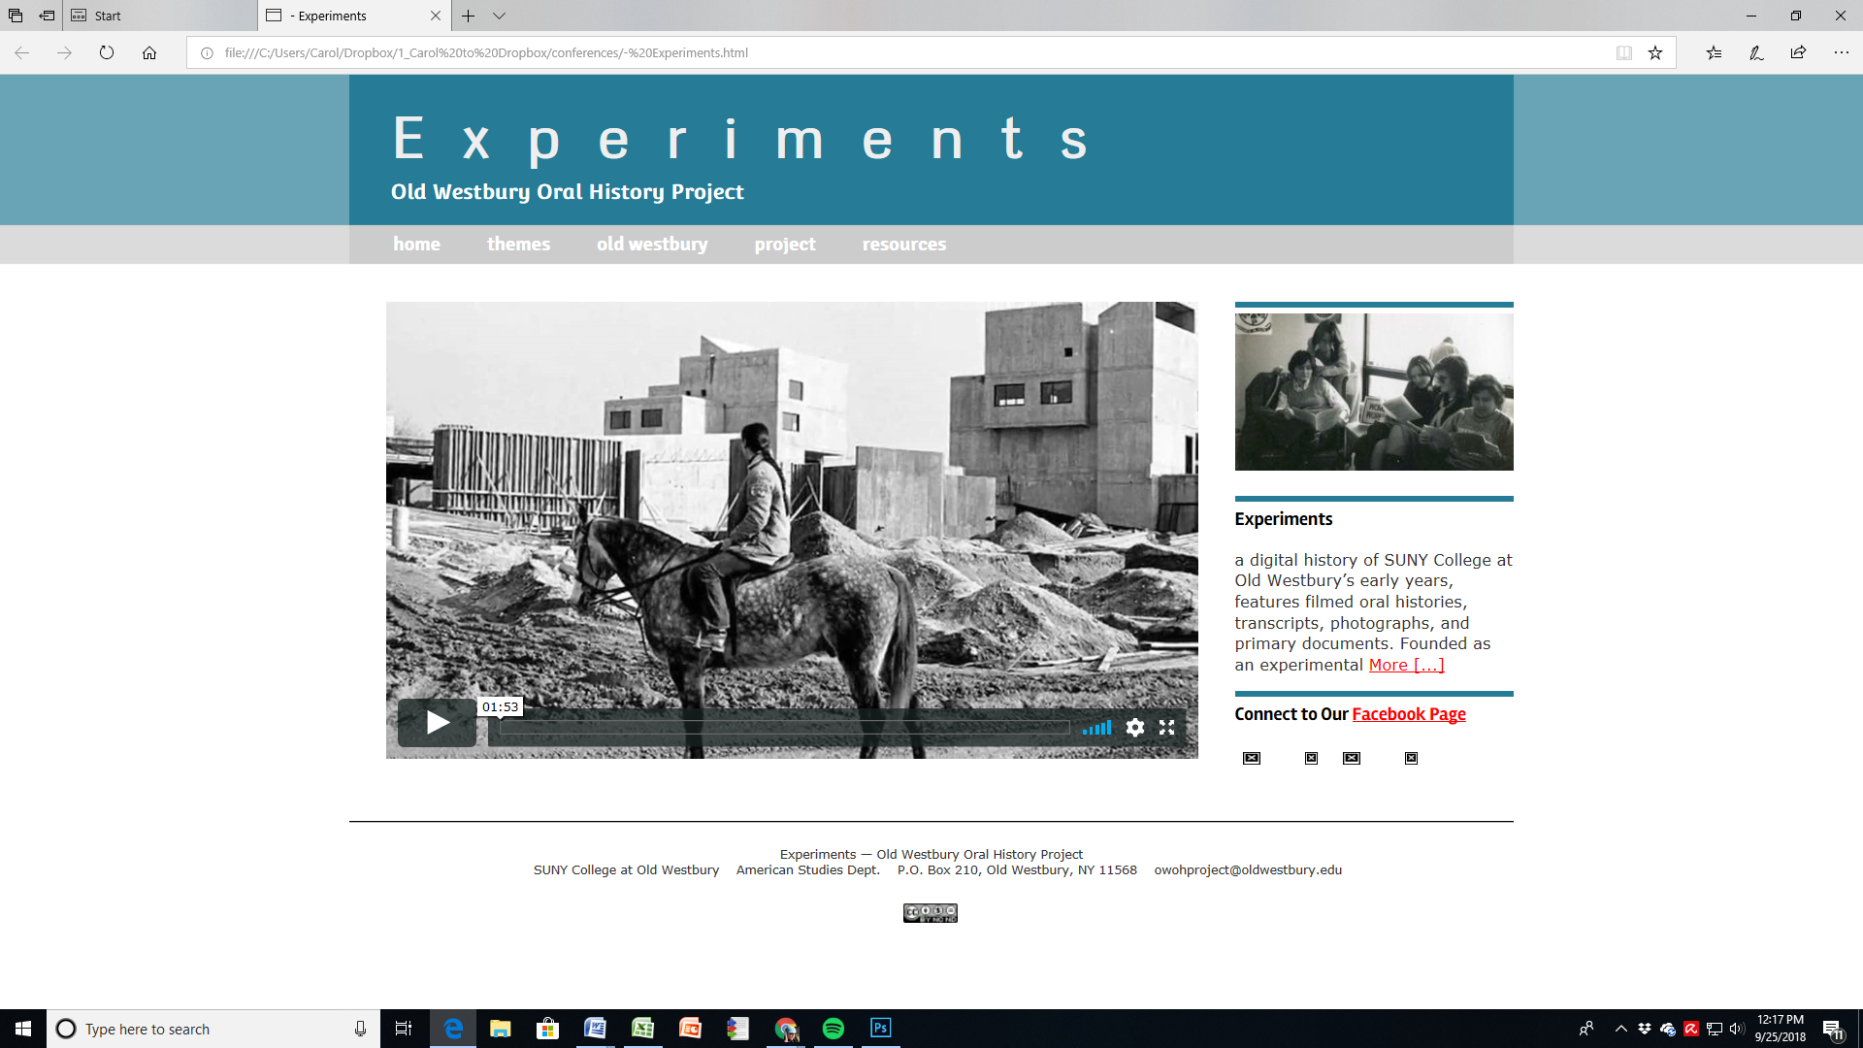

This lesson plan takes advantage of Experiments: Old Westbury Oral History Project, developed by Old Westbury’s American Studies Department from 2011-2013. http://www.oldwestburyoralhistory.org/

The digital oral history project and archive, which contains video interview clips, full transcripts, and primary sources including photographs could be used in multiple courses, including First Year/Ethics of Engagement, Postwar America, African American studies, History of Colleges and Universities, or the History of the 1960s.

Objective(s):
- To understand the expansion and democratization of higher education in postwar America, and forces promoting greater inclusivity in higher education through a case study of one SUNY liberal arts college;
- To understand historically how students and faculty have understood the relationship between higher education and civic engagement and/or activism;
- To understand the political stakes and effects of campus turmoil in the 1960s, and assess college participants’ understanding of the impact of their engagement, both socially and personally;
- To engage in the act of history by creating a narrative/thesis using conflicting stories and primary sources.
- (Particularly for civic engagement courses) To reflect on the meaning of higher education—as an institution within society, and for participants within institutions of higher education.

Student Activities:

Exercises using Experiments: Old Westbury Oral History Project
Primary Source Analysis #1 Old Westbury Beginnings

For Students
Reading: SUNY College at Old Westbury, “Statement of First College,” September 1968 or 1972 “College Guide”

Question: Identify the educational, social, and/or political values that sustained the first college’s mission and make a list of them. Use direct references to the “Statement” or “College Guide”.

Write a 250-500 word explanation of what you believe the educational, social and/or political values motivating the college’s mission. Feel free to raise other issues raised by either primary source (1-2 pages)

In Class: Break students up into small groups of three or four to discuss the values they identified. What common themes emerge? What questions do students have about the first college at Old Westbury? What surprises students about discussions of higher education’s mission half a century ago.

For a class on the history of universities it might be helpful to compare and contrast OW’s “Statement of First College,” with earlier examples of missions—for examples Harvard University’s 1650 charter: https://emeritus.library.harvard.edu/university-archives/using-the-collections/online-resources/charter-of-1650; University of Virginia’s origins in “A letter from Thomas Jefferson to the late Peter Carr,” September 7, 1814 in 384-390, and “An Act for Establishing a College in the County of Abermarle, 391-393 both in Nathaniel Francis Cabell, Early history of the University of Virginia, as contained in the letters of Thomas Jefferson and Joseph C. Cabell (Richmond VA: JW Randolph, 1856), at https://babel.hathitrust.org/cgi/pt?id=nyp.33433074836200;view=1up;seq=422; and Robert M. Hutchins (former University of Chicago President—opponent to GI Bill, advocate for liberal arts education) “The Idea of A College,” originally published in Measure 1 (Fall 1950): 363-371. Reprinted in Engaging the Humanities at the University of Chicago, ed. Philippe Desan (University of Chicago Press, 1995). Available at http://www.ditext.com/hutchins/1950.html

For Professor—Assignment Techniques
- Identify in advance particular themes that seem noteworthy or worth development for your course. Possible themes include: what constitutes college inquiry and the liberal arts tradition? What is the relationship between professor and student? What were the pressing issues of education in the late 1960s, as college was being democratized?
Primary Source Analysis #2. Old Westbury Values and Mission
To Students
Old Westbury—Perspectives on the Past
Readings: Transcript Interviews of Presidents John Maguire and Harris Wofford, Faculty Liz Ewen, Samuel von Winbush, Carlos Russell, Alumni Francis Koster, Ghebre Mehreatab, Deborah Leavy, Frank Miata, & Candida De Luise.

Question: Using your interview as a primary source, describe some of the most important things you learn about OW (a college education) from the interview. Do the narrators’ views coincide about events and/or the meaning of Old Westbury, or do they disagree? What themes emerge from the interviews? Pick out some key quotes that make the narrators’ point, or are strong quotes to sustain your observations. (2-3 pages)

For Professor--Assignment techniques
- Give each student three distinct interviews so that they get three divergent viewpoints on Old Westbury.

- Make sure that each student has a mix of administrator, student and faculty viewpoints.

- Cross fertilize—so that no group of students have the same mix of interviews. (Conversely, you could create groups that are the same, and have them do group work to determine common themes, then share with classroom to see if there are differences between groups. Such groups could be divided by race and or gender; by status at college, or by specific themes, for examples radicals vs. reformers.)

- Class discussion questions.

What motivated narrators to come to Old Westbury?

How do the social movements of the 1960s (or earlier) feed narrators’ activism?

What problems did Old Westbury encounter? Why do you think these problems occurred? Could something have been done to address conflict at Old Westbury?

What, in our narrators’ views, are the advantages of Old Westbury diversity?

What are some of the difficulties students, faculty and administrators faced due to the college’s diversity?

What limits did you perceive in these interviews? Were there topics you believed they did not explore, biases you thought the narrator exhibited? What more would you need to know to identify if such bias or limits existed?

Learning outcomes
- Acquaintance with social movements, educational diversity, and educational democratization in the postwar era.
- Practice identifying key historical issues in narrators’ terms, and identifying divergent perspectives
- Development of argument utilizing historical primary sources
- Awareness of limits and possibilities of oral history testimony

Synthesizing History

For Students

Reading: Primary Sources: Mugbook, Kranes, “The Anatomy of State U,” Wofford, “Creating an Experimental College of a State University.”
Secondary Sources: John Thelin, A History of American Higher Education (Baltimore, Johns Hopkins University Press, 2011; Ula Taylor, “Origins of African American Studies at UC Berkeley,” Western Journal of Black Studies, Summer 2010 34 (2) 256-265; Robert Chrisman, “The Black Scholar: The First Forty Years,” Black Scholar v 41, n 4, (Winter 2011): 2-4; John Bunzel, “Black Studies at San Francisco State, The Public Interest, No. 13, (1968): 22-38; Catherine Orr, Telling of our Activist Pasts: Tracing the Emergence of Women’s Studies at San Francsisco State College, Women’s Studies Quarterly, v 27 nos 3-4 (1999): 212-229.

Question: How was education democratized at the end of the 20th century? How does Old Westbury fit into this trend?

Learning Outcomes

- Identification of key issues in transformations in U.S. higher education, including the student body composition, shifts in curriculum, and challenges in these changes.
- Use of primary and secondary sources to make an argument.
- Utilization of localized case study and macro views of trends in higher education

Time Needed:

Supplies for this Activity:

Activity:

Teacher’s Notes on the Activity:

Experiments oral histories and digital archive offers rich evidence on multiple themes, but these are some of the obvious lessons provided by this project.

